SIMPLE IT ASSET & ISSUE DESK
@CREATIVITY THINK (9483175986/7019689991)

ABSTRACT:
Simple IT Asset & Issue Desk is a web-based application designed to streamline IT asset tracking and issue resolution workflows within organizations such as colleges, offices, labs, and co-working spaces. The system allows employees to view assigned devices, raise issue tickets, track progress, communicate with IT staff, and rate the support received. IT administrators can manage the asset registry, assign assets to employees, prioritize and assign issue tickets to technicians, log resolution notes, and monitor overall IT efficiency through dashboards and SLA-based analytics. Built using Django REST Framework and React, this platform ensures secure, efficient, and transparent IT support management..

INTRODUCTION OF THE PROJECT:
Modern workplaces rely heavily on IT infrastructure, and managing devices, tickets, and support workflows manually often leads to delays, lost information, and inefficiencies. The Simple IT Asset & Issue Desk addresses these problems by providing a centralized digital platform where employees can quickly report issues and IT teams can efficiently track, diagnose, and resolve them. With structured workflows, real-time status updates, and analytics dashboards, the system enhances productivity, reduces downtime, and improves communication between users and IT administrators..

PROJECT OBJECTIVES:

• Maintain a complete registry of IT assets
• Assign assets to employees with proper tracking
• Allow employees to submit issue tickets for assigned devices
• Enable real-time status tracking and two-way communication
• Allow technicians to update progress and resolution notes
• Provide ratings for service experience
• Create an analytics dashboard for IT administrators
• Track SLA breaches and unresolved tickets
• Support monthly report exports
• Improve transparency, accountability, and response speed

PROBLEM OF THE STATEMENT:
Organizations often face challenges in managing IT assets and support tickets due to manual or fragmented processes. Issues such as untracked devices, unresolved complaints, and lack of status visibility result in downtime and reduced productivity. The Simple IT Asset & Issue Desk provides a structured and transparent solution, ensuring proper asset mapping, quick issue reporting, efficient ticket resolution, and comprehensive analytics for informed decision-making..

MOTIVATION OF THE PROJECT:
• To reduce downtime in workplaces by ensuring structured IT support
• To prevent asset loss or mismanagement through a centralized registry
• To create clear communication between employees and IT technicians
• To offer transparency in ticket status and SLA tracking
• To improve service quality through feedback and analytics
• To simplify IT team operations with dashboards and automated logs
• To support digital transformation in modern office and academic spaces

BLOCK DAIGRAM OF PROJECT:

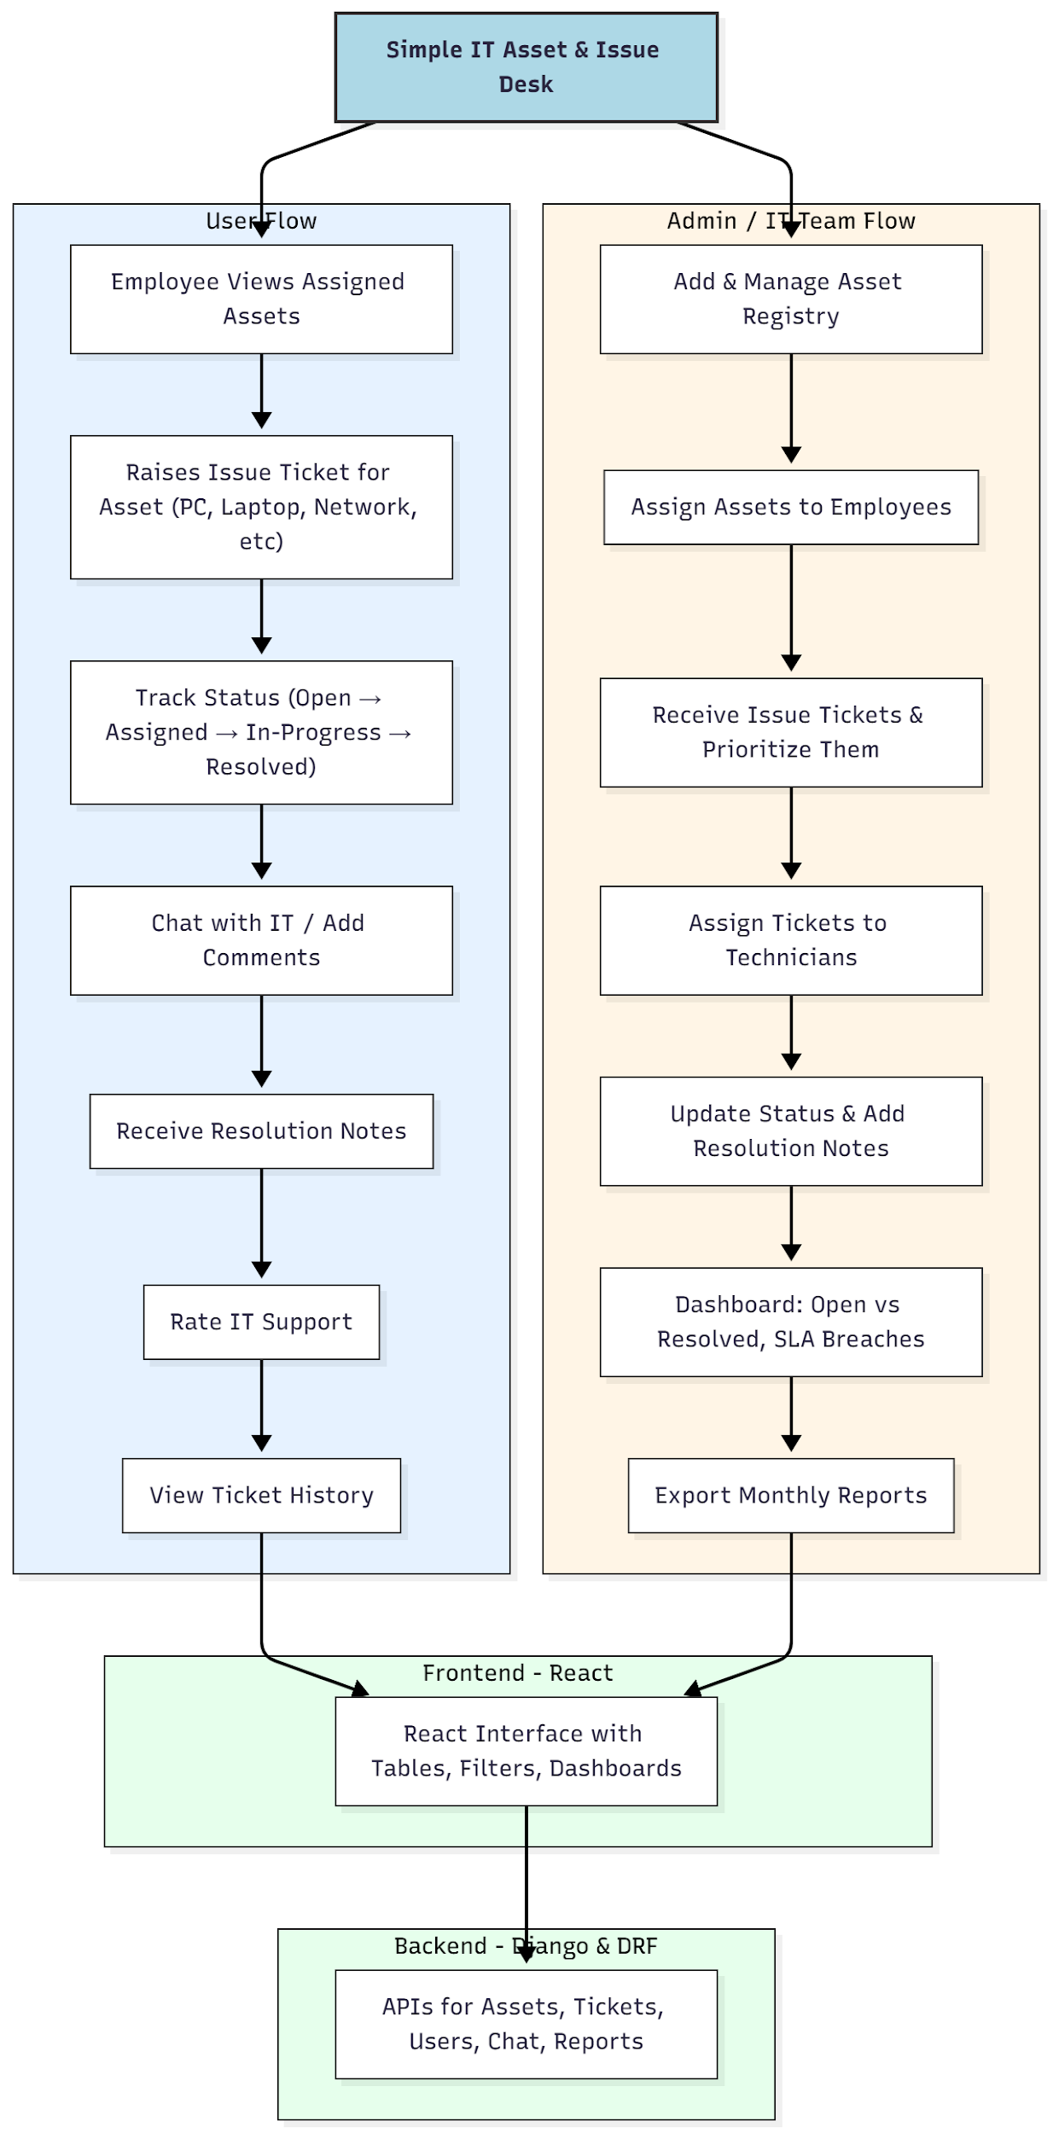

WORKING OF THE PROJECT:
Employees log in to the system and view the IT assets assigned to them. When a device issue arises—such as slow performance, network problems, or hardware malfunction—they raise a support ticket through the portal. The ticket enters the IT admin dashboard, where it is categorized, prioritized, and assigned to a technician.
Technicians update the ticket status as they work on it and add resolution notes once the issue is fixed. Employees receive notifications and can chat with IT staff if clarification is needed.
The system dashboard shows ticket trends, SLA breaches, and open vs resolved tickets. At the end of each month, admins can export reports for audits or documentation..

SOFTWARE REQUIREMENT:
- Backend:
  - Python 3.x
  - Django
  - Django REST Framework
  - SQLite/PostgreSQL
- Frontend:
  - Node.js and npm
  - React.js
  - Axios
- Development Tools:
  - Visual Studio Code
  - Postman (for testing APIs)
  - Git/GitHub (for version control)
- Server/Deployment (Optional):
  - Gunicorn, Nginx, or Heroku/AWS for hosting

ADVANTAGES OF THE PROJECT:

• Streamlined IT support workflow
• Full visibility of asset assignments and ticket history
• Faster response time and reduced downtime
• SLA-based monitoring improves performance
• Transparent communication via built-in chat/comments
• Efficient technician assignment and prioritization
• Data-driven decision-making through dashboards
• Accurate documentation via monthly exportable reports

APPLICATIONS OF THE PROJECT:
• Corporate offices
• Colleges and universities
• Computer labs
• Co-working spaces
• IT service desks
• Small and medium businesses

REFERENCES:

- Django REST Framework Documentation — Django Software Foundation. Django Documentation. Available: https://docs.djangoproject.com/
- Django REST Framework. DRF Documentation. Available: https://www.django-rest-framework.org/
- React. React Official Documentation. Available: https://reactjs.org/docs/getting-started.html
- Redux. Redux Documentation. Available: https://redux.js.org/introduction/getting-started
- PostgreSQL Global Development Group. PostgreSQL Documentation. Available: https://www.postgresql.org/docs/
- MySQL. MySQL Reference Manual. Available: https://dev.mysql.com/doc/
- Git. Git Documentation. Available: https://git-scm.com/doc
- Node.js. Node.js Documentation. Available: https://nodejs.org/en/docs/
- Axios. Axios Documentation. Available: https://axios-http.com/docs/intro
- Socket.io Documentation – https://socket.io/docs/

